Project Identification

Project: | GBC Parking Reservation System
Prepared By: | Afsana Bilkis Ritu
Document Version: | 1.0
Published Date: | 2019-09-28

Contributors
Name | Title
Beatriz | Student
Jin | Student
Afsana | Student
Geng Zhang | Student

Distribution
Name | Title
Anjana Shah | Instructor

Referenced Documents
Version number | Title | Author | Date | Source / Location

Revision History

Version Number | Revision Date | Summary of Changes | Modified by

TABLE OF CONTENTS
1. Business Context Diagram 3
2. REquirements Scope Statements 4
3. High Level Business Requirements (HLR) Traceability 4
4. High Level Business Requirements Sign-Off 5

1. Business Context Diagram:

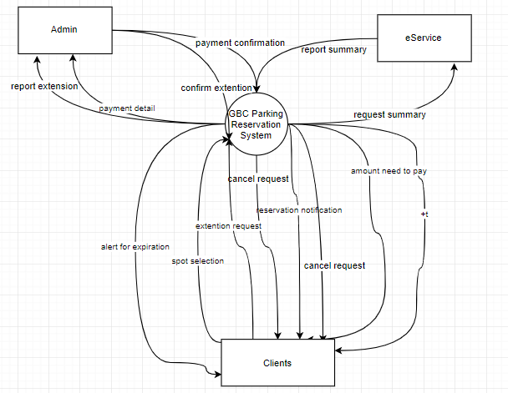

Requirement Scope Area | Description
GBC Parking Reservation System | This web system will offer clients to reserve the parking slots before entering in the college.

External Entity | Description
eService | External area that will store clients details like payment history, reservation confirmation and clients details.
Clients | Clients who can view available slots, reserve slots and even cancel reservation
Admin | GBC employee who can confirm reservation,payment and ensure the extension

Information Flows | Description
Spot selection | After logging in, the system will show the parking spot selection interface. User will select the lot and then the spot they wish to reserve (if available). User will then input their name and license plate number in order to reserve the spot.
Parking Payment | Amount of parking fee will be calculated based on the time slot picked by the client e.g, 2 hours, 4 hours.
Recording report | The system will record time slot picked, license plate, parking spot, id, name etc.
Summary report | The system will demonstrate the summary report based on the request of admin
Payment confirmation | The admin will verify the payment of the client
Extension request | If any client needs an extension they can request it and the system  Will offer extra time depending on the availability.
Reservation notification | The system will notify the client about the confirmation of  reservation.
Alert for expiration | Before the expiration of the reservation the client will get an alert  message
Cancelling booking | One can easily cancel the reservation, but it has to be within a  limited period of time
Report Extension | The system will report the extension request for booking and admin  will confirm it
Amount needed to pay | The system will deliver the bill of charges to the client

Requirements Scope Statements
HLR# | Description | Priority  (H, M, L)
 | Clients must be able to request for available parking slots | H
 | Clients must be able to view available slots | H
 | Clients must get notification for parking confirmation | M
 | Clients must be alerted before the expiration of reservation | M
 | Admin must be able to confirm reservation | H
 | Admin must be able to get the detailed information of clients | H
 | Clients must get payment history | H

High Level Business Requirements Sign-Off
The undersigned acknowledge their agreement with the contents of Version <1.0> of the High-Level Requirements document for <GBC Parking Reservation System>.

Following approval of this document, requirements changes will be governed by the project’s change management process, including impact analysis and appropriate reviews and approvals, under the general control of the Project Plan and according to company policy. Approved Change Request Documents, if present, will be attached to this Requirements Document as updates.

Name | Project Role and  Functional Area | Date Signed
Geng Zhang | Developer | 09/28/2019
Jin Kwan Kim | Developer | 09/28/2019
Beatriz Morales | Developer | 09/28/2019
Afsana Bilkis Ritu | Developer | 09/28/2019

* Note: physical signatures are not required. Email approvals are acceptable and should be appended to project documents.

